User Story-004

Testcase -001 : Functionality Check for cart symbol

Step1: Navigate to the URL of the opencart site 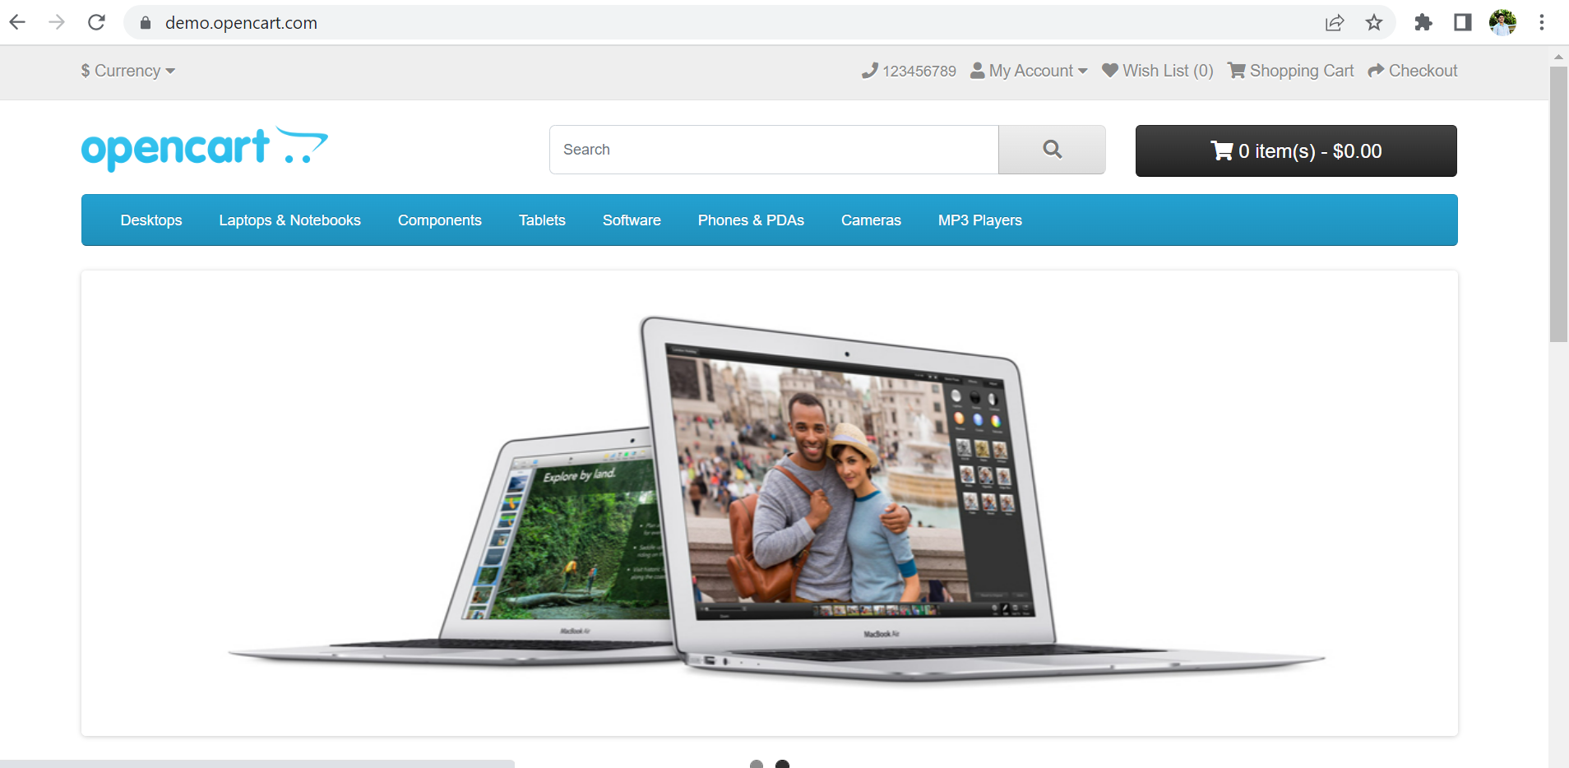

Step3: Navigate back to the homepage and click on the Shopping cart option which is available on the top right corner of home page

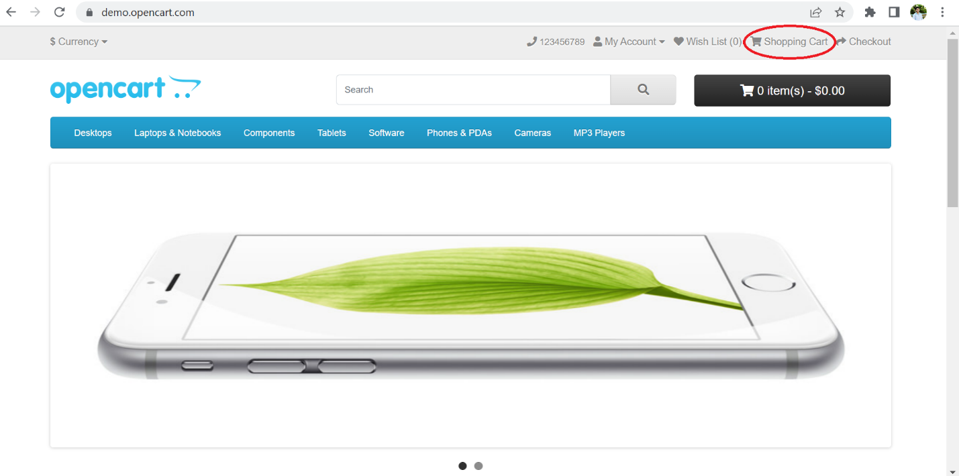

Step4: User should be able to see the empty cart

**All the steps are passed and testcase-001 executed successfully.**